Full Version: The Chaos Thread
You're currently viewing a stripped down version of our content. View the full version with proper formatting.
Pages: 1 2 3 4 5 6 7 8 9 10 11 12 13 14 15 16 17 18 19 20 21 22 23 24

Leonartist
11-21-2012, 07:55 PM
Help fight thread pollution (if we have any). Post here if it isn't worth making another thread.

DysLabs
11-21-2012, 08:48 PM
Erm....
Wrong section?

Ghosty
11-21-2012, 08:49 PM
And I hope we don't need this. The Chaos thread was one of the causes of community decline. It's not bad per se, but we need to be careful about how we use it. As a random noticeboard, it's better than a dozen new threads, but it still has to have some discussion value of some sort.

Leonartist
11-22-2012, 12:16 PM
No Nyan cats

Anyway, Why is Walrus banned?

Leonartist
11-23-2012, 03:10 PM
^ Its the chaos thread.

Emperor
11-24-2012, 07:59 AM
Sorry, I deleted that post I made.

Leonartist
11-25-2012, 02:42 PM
QQ Why is Walrus banned?

Void
11-25-2012, 04:06 PM
(11-25-2012 02:42 PM)Leonartist Wrote: [ -> ]QQ Why is Walrus banned?
Because started causing mass drama here.

Ghosty
11-26-2012, 10:36 AM
So I took a closer look at the logo on my heater...
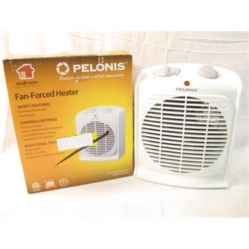
Caution: keep away from combustible materials such as furniture, pillows, bedding, papers, clothes, and curtains.
And lemons.

Emperor
11-26-2012, 03:00 PM
@Ghosty
Wat

Ghosty
11-26-2012, 03:17 PM

Leonartist
12-01-2012, 01:10 PM
(11-26-2012 10:36 AM)Ghosty Wrote: [ -> ]So I took a closer look at the logo on my heater...
Caution: keep away from combustible materials such as furniture, pillows, bedding, papers, clothes, and curtains.
And lemons.
Subliminal messages.

Ghosty
12-07-2012, 11:09 AM
This is awesome.

Myem
12-07-2012, 09:09 PM
Jacob_, why did you delete my "iloominaete" response to Leonartist? Would you prefer if I start a whole thread dedicated to calling everything an "illominatie subliminal message" rather than posting in the thread that was meant for such?

Ghosty
12-12-2012, 05:13 PM
For some reason, I found this mildly amusing.
Jeff Jeff Jeff Jeff Jeff Jeff Jeff DOMO!

Innerwebs
12-12-2012, 09:08 PM
Made a new profile pic for Steam. The shading takes up about 30 layers

Ghosty
12-13-2012, 04:00 PM
I decided to experiment with recording my Minecraft gameplay via Twitch.tv. I can't commentate on it verbally, AND my sound is buggy so there might be no audio whatsoever. But I do use the new(as of MC 1.3) SSP chat system to commentate as I go So far, among other things, I have gotten antlers (thanks to a skeleton), fallen down a cliff and died (and then gotten all my stuff back yay), gone on several semi-epic quests for sugarcane, and discovered that Forestry's balsa trees are apparently actually made of stone.
http://www.twitch.tv/qwertygiy/videos?ki...broadcasts

Ghosty
12-14-2012, 03:29 PM
I never realized until today that "When I Ruled the World" by Coldplay was actually titled "Viva La Vida", and that CaptainSparklez's Minecraft parody video, "Fallen Kingdom", was actually of that song.
I seriously need to look things up more often.

Void
12-14-2012, 03:32 PM
(12-14-2012 03:29 PM)Ghosty Wrote: [ -> ]I never realized until today that "When I Ruled the World" by Coldplay was actually titled "Viva La Vida"
Yeah, and it's about Napoleon.

Ghosty
12-14-2012, 03:37 PM
(12-14-2012 03:32 PM)Void Wrote: [ -> ]
(12-14-2012 03:29 PM)Ghosty Wrote: [ -> ]I never realized until today that "When I Ruled the World" by Coldplay was actually titled "Viva La Vida"
Yeah, and it's about Napoleon.
I can see that pretty easily.
One of the first times I heard it, though, was as Muzak in a Little Caeser's Pizza Shop, so for some reason I always associated it with Rome until now.

DysLabs
12-14-2012, 03:47 PM
(12-14-2012 03:37 PM)Ghosty Wrote: [ -> ]
(12-14-2012 03:32 PM)Void Wrote: [ -> ]
(12-14-2012 03:29 PM)Ghosty Wrote: [ -> ]I never realized until today that "When I Ruled the World" by Coldplay was actually titled "Viva La Vida"
Yeah, and it's about Napoleon.
I can see that pretty easily.
One of the first times I heard it, though, was as Muzak in a Little Caeser's Pizza Shop, so for some reason I always associated it with Rome until now.
-_-

Myem
12-14-2012, 05:07 PM
(12-14-2012 03:47 PM)DysLabs Wrote: [ -> ]
(12-14-2012 03:37 PM)Ghosty Wrote: [ -> ]
(12-14-2012 03:32 PM)Void Wrote: [ -> ]
(12-14-2012 03:29 PM)Ghosty Wrote: [ -> ]I never realized until today that "When I Ruled the World" by Coldplay was actually titled "Viva La Vida"
Yeah, and it's about Napoleon.
I can see that pretty easily.
One of the first times I heard it, though, was as Muzak in a Little Caeser's Pizza Shop, so for some reason I always associated it with Rome until now.
-_-
le unamused fas

Jacob_
12-15-2012, 01:51 PM
There's a whole lot of forums using my chat plugin... https://www.google.com/search?q=%22mybb%..._frame.php

Ghosty
12-16-2012, 08:06 PM
So, for a couple days this week, I'm going to go back up to the town I left last year. I'll get to see one of my old friends and hang out at his house for a while.
I was also pretty excited because it meant I might get to see Mysty.
But unfortunately, during the time period I would be able to go see her, she's busy with school and other appointments.
And such is the stupid luck that has befallen me most of my life. :/ Even when things look up for a moment... there's a catch.

Tax
12-18-2012, 08:46 PM
Can someone please tell me who this "Mysty" is already?!?!?!?!?!?

Ghosty
12-18-2012, 08:47 PM
Your mom.
(See, I can haz humor.)
If you don't know, you were really not paying attention on Buildism.

Ghosty
12-21-2012, 08:16 PM
Thanks to a massive unexpected shift of schedules, I did get to see Mysty today
Also, the world's still here. Just like it was yesterday. And last week. And last month. And last year. And last decade. And last century.

Leonartist
12-21-2012, 08:45 PM
Is Mysty your girlfreind?

Ghosty
12-21-2012, 08:48 PM
She would probably punch you for saying that.

DysLabs
12-22-2012, 01:30 PM
(12-15-2012 01:51 PM)Jacob_ Wrote: [ -> ]There's a whole lot of forums using my chat plugin... https://www.google.com/search?q=%22mybb%..._frame.php
Link?
;o

http://mods.mybb.com/view/ajax-chat
Invalid Download.
qq

Jacob_
12-22-2012, 02:20 PM
I updated it and it has to be approved, and the moderators there really like to procrastinate.
http://buildism.net/mybbmods

DysLabs
12-22-2012, 02:32 PM
You redid Buildism?
And thanks.

http://buildism.net/files/ajaxchat.zip
404 Not Found
qqqqqqqqqqqqqqqqqqqqqqqq

Kieron
12-22-2012, 03:02 PM
I'm happy with myself.
Yesterday, I could barely do 10 push-ups in 10 minutes. Now I can do 30 in half a minute. :>

Leonartist
12-22-2012, 10:39 PM
When I get some Christmas money, I'm going to buy a canvas, and some paints. I
plan on painting a dark hallway scene that fades into blackness, and I'll post pics of it
as I work on it.

Leonartist
12-23-2012, 02:18 PM
http://www.youtube.com/watch?v=3y7sngsvong
I never understood this video.

DysLabs
12-23-2012, 03:09 PM
You weren't there when that happened.
I get it.

Leonartist
12-23-2012, 03:19 PM
So what happened?

Ghosty
12-24-2012, 11:24 AM
"Jarrett" was sergentkyle. His sister made an account and the mods thought it was him.

Ghosty
12-27-2012, 09:16 PM
Suddenly my own piano-playing and medley-making skills look like a toddler playing around with a xylophone.

Leonartist
01-01-2013, 08:10 PM
No one uses the OT emoticon.

Ghosty
01-01-2013, 08:10 PM
No, nobody ever uses Mr. Green.

Jacob_
01-02-2013, 05:55 PM
I made a website... http://onlinesequencer.net/
Someone recreated the Mario theme: http://onlinesequencer.net/48

Ghosty
01-02-2013, 06:03 PM
OMG MUSIC MAKER PIANO THINGY. MUST USE. Reserving this post for my 'compositions'
http://onlinesequencer.net/107 -- The melodic looping bit of Fireflies, by Owl City
http://onlinesequencer.net/116 -- Reconstructing More Science, from Portal 2
http://onlinesequencer.net/143 -- A Ragtimey version of Still Alive.

Jacob_
01-02-2013, 06:14 PM
There's some more stuff that people have made in this thread: http://www.reddit.com/r/tipofmytongue/co...d_a_music/

Void
01-02-2013, 07:06 PM
Made this
http://onlinesequencer.net/111

Ghosty
01-02-2013, 07:16 PM
HA! I also just made Reconstructing More Science! :P
http://onlinesequencer.net/116

DysLabs
01-02-2013, 07:28 PM
kewl @Jacob_

Ghosty
01-02-2013, 08:28 PM
Browsing through IDs, someone made the Tetris theme: http://onlinesequencer.net/126
And I don't know what this is but it's EPIC: http://onlinesequencer.net/129
This is fun. It really needs its own thread.

DysLabs
01-02-2013, 08:37 PM
Sadly I still don't have sound on my computer.

Void
01-02-2013, 10:02 PM
(01-02-2013 08:28 PM)Ghosty Wrote: [ -> ]This is fun. It really needs its own thread.
It needs it's own subreddit.

Myem
01-02-2013, 11:05 PM
(01-02-2013 10:02 PM)Void Wrote: [ -> ]
(01-02-2013 08:28 PM)Ghosty Wrote: [ -> ]This is fun. It really needs its own thread.
It needs it's own subreddit.
It needs its own Wikipedia article.

Leonartist
01-03-2013, 05:03 PM
http://www.youtube.com/watch?v=XS92MVBzq6Y
I can't get this song out of my head.

Ghosty
01-05-2013, 05:01 PM
Tinypic, you're doing Captchas the right way.

VenomSinister
01-06-2013, 01:25 PM
Ghosty, that is obviously fake. :P

Ghosty
01-06-2013, 01:43 PM
Well of course it's not a picture of a real ninja squirrel. Do you know how rare those are?!

Leonartist
01-06-2013, 04:38 PM
(12-22-2012 10:39 PM)Leonartist Wrote: [ -> ]When I get some Christmas money, I'm going to buy a canvas, and some paints. I
plan on painting a dark hallway scene that fades into blackness, and I'll post pics of it
as I work on it.
I started the painting today. I decided to make a room with colorful sides. It has a door on the right and a long window on the left.

Leonartist
01-10-2013, 07:28 PM
test

It actualy works!

Jacob_
01-10-2013, 10:34 PM
I think I found Franco.

VenomSinister
01-11-2013, 02:37 AM
Jacob_, is that really true? Can you tell me more about him. :/

Myem
01-11-2013, 08:17 PM
(01-11-2013 02:37 AM)VenomSinister Wrote: [ -> ]Jacob_, is that really true? Can you tell me more about him. :/
His goal is to invent the time machine so he can go back in time when the gold standard was still prevalent across the international community to steal all of the gold stored in banks and jews so that he could someday make the American and Euro superpowers cease to exist.
Trust me, I played all his games.

Myem
01-11-2013, 09:55 PM
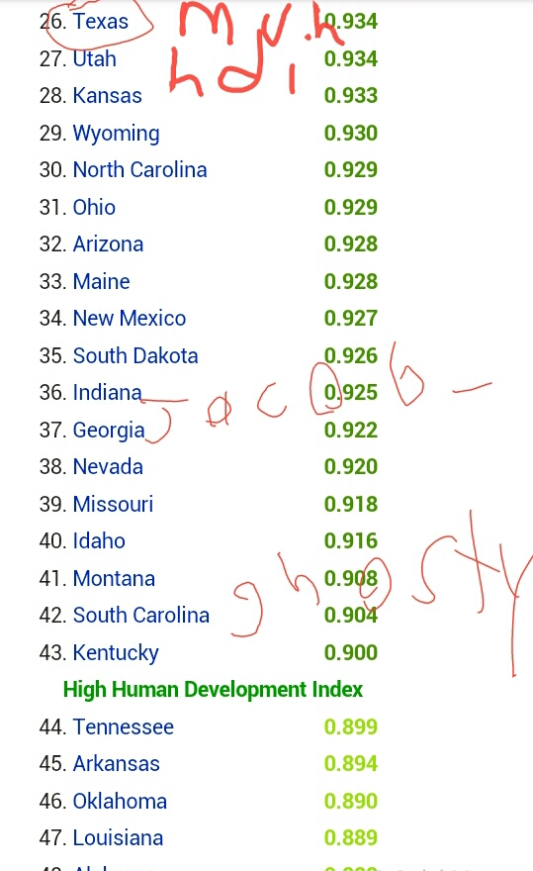
Feels good to be superior.

Void
01-11-2013, 11:52 PM
(01-11-2013 09:55 PM)Myem Wrote: [ -> ]
Feels good to be superior.
i sit at 31
yay i guess

Leonartist
01-12-2013, 12:37 AM
(01-11-2013 09:55 PM)Myem Wrote: [ -> ]
Feels good to be superior.
You're forgeting another superior who happens to be a Texan.

Ghosty
01-12-2013, 09:02 AM
Actually I should be at #30, shouldn't I? Because I only moved to SC a couple years ago
So yer only 4 places better than me. And I don't see Washington on the list, which is where Jacob's from. :P

Glome
01-13-2013, 09:21 PM

Corgi
01-13-2013, 10:17 PM

DysLabs
01-14-2013, 02:57 PM
I'm creating a '2DWorlds' chatbot, like we did on Buildism.
It won't do much good until/if we get chat back, obviously.

ITS WORKING!!!!!!!

DysLabs
01-14-2013, 03:57 PM
Sorry about the mass-spam it just caused.

Myem
01-14-2013, 10:58 PM
(01-14-2013 02:57 PM)DysLabs Wrote: [ -> ]I'm creating a '2DWorlds' chatbot, like we did on Buildism.
It won't do much good until/if we get chat back, obviously.

ITS WORKING!!!!!!!
Every time it spammed that phrase, "I'm sorry, what?" I felt unbearable anger against you, that thing, and whoever was using it. I guess not having to withstand the most artificial question that humanity has ever conceived is the good thing about not having a chat.

Ghosty
01-15-2013, 09:22 AM
In the book I read last night ['Always October' by Bruce Coville], there is a monster called Teelamun.
I'm keepin' my eye on you, Shedletsky...

Pages: 1 2 3 4 5 6 7 8 9 10 11 12 13 14 15 16 17 18 19 20 21 22 23 24

Who
01-15-2013, 06:30 PM
So I saw "The Hobbit" the other day. Great movie, but not as good as the book.

Myem
01-15-2013, 06:47 PM
(01-15-2013 06:30 PM)Who Wrote: [ -> ]So I saw "The Hobbit" the other day. Great movie, but not as good as the book.
Apparently nothing is good as the book.

Corgi
01-15-2013, 11:03 PM

Myem
01-15-2013, 11:39 PM
Every time Leonartist deletes a thread a 1000 Palestinian children die from Israeli rockets. You better think twice before erasing your footprint, leon.

(11-21-2012 08:49 PM)Ghosty Wrote: [ -> ]And I hope we don't need this. The Chaos thread was one of the causes of community decline. It's not bad per se, but we need to be careful about how we use it. As a random noticeboard, it's better than a dozen new threads, but it still has to have some discussion value of some sort.
Discussional value? Why not just delete every thread but this and see how discussional we get? That's how we get inactive, because you think there is too much when in reality having 10 Walruses around would benefit this site more than any purge of threads and users will.
Prove me wrong.

Jacob_
01-16-2013, 11:50 AM
You can't delete your own threads anymore.

DysLabs
01-16-2013, 03:31 PM
(01-16-2013 11:50 AM)Jacob_ Wrote: [ -> ]You can't delete your own threads anymore.
TAKE THAT BG

Myem
01-16-2013, 04:32 PM
(01-16-2013 03:31 PM)DysLabs Wrote: [ -> ]
(01-16-2013 11:50 AM)Jacob_ Wrote: [ -> ]You can't delete your own threads anymore.
TAKE THAT BG
*leonartist

Leonartist
01-16-2013, 06:54 PM
Who cares that I deleted one thread. Jacob was the one who deleted THREE of my threads. Here is a list of threads he deleted of mine on 2DWorlds:
"I've returned from a long journey" In this thread I pretended to be Franco
"Walrus is now the new Franco" The thread was basically just the title.
"In reply to Jacob" What happened was after I was unbanned, I complained in another thread about my bannishment being unreasonable. What happened was that I made an alt, but I did not say who I was. This got me banned for two weeks, and my alt was deleted just because its username was the F-word. When Walrus was banned for making an alt, he got to keep his alt. The rules in 2DWorlds state that you can swear, but they never said you couldn't make an account with a swear word in it. It never made any sense.
If we could still delete posts right now, and this nonsense continued, I might've considered deleting the chaos thread.

Innerwebs
01-16-2013, 07:15 PM
Dat new name.

Myem
01-16-2013, 07:24 PM
(01-16-2013 06:54 PM)Leonartist Wrote: [ -> ]Who cares that I deleted one thread. Jacob was the one who deleted THREE of my threads. Here is a list of threads he deleted of mine on 2DWorlds:
"I've returned from a long journey" In this thread I pretended to be Franco
"Walrus is now the new Franco" The thread was basically just the title.
"In reply to Jacob" What happened was after I was unbanned, I complained in another thread about my bannishment being unreasonable. What happened was that I made an alt, but I did not say who I was. This got me banned for two weeks, and my alt was deleted just because its username was the F-word. When Walrus was banned for making an alt, he got to keep his alt. The rules in 2DWorlds state that you can swear, but they never said you couldn't make an account with a swear word in it. It never made any sense.
If we could still delete posts right now, and this nonsense continued, I might've considered deleting the chaos thread.
At least I'd still have my precious dots.

Leonartist
01-17-2013, 06:39 PM
Why did you delete my image Jacob_!?! Where in the rulebook does it say that you are not allowed to post pics of poop?

Innerwebs
01-17-2013, 07:18 PM
Shock images.
And since HE runs the site, he can delete anything he pleases.

Leonartist
01-17-2013, 07:24 PM
Pictures of poop aren't shock images. Everyone has seen it, and everyone has made it. Jacob_ is abusing his power, and he has so many rules that aren't put on the site. So how are people going to follow these rules?

Innerwebs
01-17-2013, 07:28 PM
You should go to a college
Take an architecture class
Get a master's degree in architecture
Become an architect
Build a bridge
And get over it

Kieron
01-18-2013, 02:16 PM
I'm pretty sure immaturity is against the rules.

DysLabs
01-18-2013, 03:44 PM
Just because the rules don't say that you can't do it doesn't mean that you should do it. (Did I fix it?) (No, but I did -Q)
Common sense ftw

VenomSinister
01-18-2013, 03:48 PM
(01-17-2013 07:24 PM)Leonartist Wrote: [ -> ]Pictures of poop aren't shock images. Everyone has seen it, and everyone has made it. Jacob_ is abusing his power, and he has so many rules that aren't put on the site. So how are people going to follow these rules?
Some people think it looks disgusting and very immature.
Think about someone eating something very delicious while reading the thread and they see that picture, the results might be very.... :/ Think.

Ghosty
01-18-2013, 03:48 PM
(01-18-2013 03:44 PM)DysLabs Wrote: [ -> ]Just because the rules say you can't do it doesn't mean you can.
Common sense ftw
Just because it says one thing doesn't mean it means that thing.
Mr. Tipo ftw

DysLabs
01-18-2013, 03:50 PM
*headtree*

(01-18-2013 03:48 PM)VenomSinister Wrote: [ -> ]very
VARY VARY VARY!
commie

VenomSinister
01-18-2013, 03:53 PM
(01-18-2013 03:50 PM)DysLabs Wrote: [ -> ]*headtree*

(01-18-2013 03:48 PM)VenomSinister Wrote: [ -> ]very
VARY VARY VARY!
commie
Very .... DISGUSTING. Nom nom. :o

Pages: 1 2 3 4 5 6 7 8 9 10 11 12 13 14 15 16 17 18 19 20 21 22 23 24

DysLabs
01-18-2013, 04:19 PM
(01-18-2013 03:53 PM)VenomSinister Wrote: [ -> ]
(01-18-2013 03:50 PM)DysLabs Wrote: [ -> ]*headtree*

(01-18-2013 03:48 PM)VenomSinister Wrote: [ -> ]very
VARY VARY VARY!
commie
Very .... DISGUSTING. Nom nom. :o
I didn't read the "be."
>.>
*headtree*

Leonartist
01-18-2013, 07:48 PM
Help fight thread pollution. Post here if its not worth making a new thread. Here is a new chaos thread since you guys cared so much about the title. I swear to God that I will never change the title of this thread. (I'm Christian)

Myem
01-18-2013, 08:02 PM
You do know that not everyone here is willing to compromise?

Ghosty
01-18-2013, 08:04 PM
Merged old thread into new thread

Myem
01-18-2013, 08:08 PM
(01-18-2013 08:04 PM)Ghosty Wrote: [ -> ]Merged old thread into new thread
Good job on solving that quarrel, but there's still something that you haven't answered yet. *Hint*

Leonartist
01-18-2013, 08:16 PM
Well you got me here, and there is only one thing left to do.
[content removed by some one]
Or I could convert to Satanism and rename the thread.

Myem
01-18-2013, 08:20 PM
(01-18-2013 08:16 PM)Leonartist Wrote: [ -> ]Well you got me here, and there is only one thing left to do.
snip
Or I could convert to Satanism and rename the thread.
Or how about acting reasonable and assessing the situation maturely?

Ghosty
01-19-2013, 09:37 AM
This guy has epic endurance skills. Check out his time spent online.
http://2dworlds.org/forum/User-Sxovuapky

Kieron
01-19-2013, 01:13 PM
I think he may have died of exhaustion.

DysLabs
01-19-2013, 09:03 PM
What happens when you go to http://vscope.tk/

Ghosty
01-20-2013, 09:12 AM
(01-19-2013 09:03 PM)DysLabs Wrote: [ -> ]What happens when you go to http://vscope.tk/
Oops! Google Chrome could not connect to vscope.tk
EDIT: The first 100th reply on 2DWorlds.

DysLabs
01-20-2013, 02:06 PM
Good. That's supposed to happen.

Myem
01-21-2013, 11:43 AM
Is anyone else watching Obama's inauguration right now?

Obama just made an embarrassing mistake by not saying "states" correctly.

Oak
01-21-2013, 12:29 PM
I am, and I don't recall him saying it incorrectly.

Myem
01-21-2013, 12:36 PM
(01-21-2013 12:29 PM)Oak Wrote: [ -> ]I am, and I don't recall him saying it incorrectly.
It was during the oath.

Oak
01-21-2013, 12:39 PM
Beyonce was also excellent as always when she sung our Anthem.
I don't like the style she does it in, but she has pure talent, no question about it and she's really attractive.

Leonartist
01-21-2013, 04:26 PM
[link deleted] --This was a moderative tool link. GOODBYE SPAMMER TOOL IS POWERFUL. -G

Jacob_
01-22-2013, 05:55 PM
(01-21-2013 04:26 PM)Leonartist Wrote: [ -> ][link deleted] --This was a moderative tool link. GOODBYE SPAMMER TOOL IS POWERFUL. -G
He can't use it, but there's no easy way to stop the URL from showing up in the who's online link.
I'm having to write 3 files of code like this for homework. Suddenly adding multiplayer to 2DWorlds doesn't seem so hard anymore...
Code:
public static int get(int num, int which)
{
int numMask = 0xFFFF << (which << 4);
num = num & numMask;
num = num >> (which << 4);
if(num < 0)
num = num & ~numMask;
return num;
}

Corgi
01-22-2013, 09:10 PM

Innerwebs
01-23-2013, 01:42 AM
(01-22-2013 09:10 PM)Corgi Wrote: [ -> ][lolsnip]
"I also love cabbage"
I'm dying.
Anyway, I looked up my name on the internet.

Ghosty
01-23-2013, 08:50 AM
(01-23-2013 01:42 AM)Innerwebs Wrote: [ -> ]Anyway, I looked up my name on the internet.
Lol, what website?

Oak
01-23-2013, 10:51 AM
(01-22-2013 05:55 PM)Jacob_ Wrote: [ -> ]
(01-21-2013 04:26 PM)Leonartist Wrote: [ -> ][link deleted] --This was a moderative tool link. GOODBYE SPAMMER TOOL IS POWERFUL. -G
He can't use it, but there's no easy way to stop the URL from showing up in the who's online link.
I'm having to write 3 files of code like this for homework. Suddenly adding multiplayer to 2DWorlds doesn't seem so hard anymore...
Code:
public static int get(int num, int which)
{
int numMask = 0xFFFF << (which << 4);
num = num & numMask;
num = num >> (which << 4);
if(num < 0)
num = num & ~numMask;
return num;
}
So is multiplayer down because you cant get it working? I thought it was because you didn't have enough server capacity or whatever.

Jacob_
01-23-2013, 04:03 PM
I could host on on the 2DWorlds server, but it has some problems and likes to crash randomly, sometimes taking down the website with it. I usually host it on my computer when people want it but nobody's asked lately.

Ghosty
01-25-2013, 12:19 PM
I had a bad night...

Myem
01-26-2013, 01:17 AM
(01-25-2013 12:19 PM)Ghosty Wrote: [ -> ]I had a bad night...
snip
General Custer 2.0?

Ghosty
01-26-2013, 09:03 AM
This was in singleplayer, believe it or not.

Kieron
01-26-2013, 01:46 PM
Surely it's just a scratch, put a bandage over it.

Leonartist
01-26-2013, 08:16 PM
http://2dworlds.org/leonartististhekingofbuildism.php

Myem
01-26-2013, 09:29 PM
(01-26-2013 08:16 PM)Leonartist Wrote: [ -> ]http://2dworlds.org/leonartististhekingofbuildism.php
"404"
Of course.

BuildistGuard
01-26-2013, 10:15 PM
There is some form of technology that you guys shouldn't buy! It's the tobii eye tracking device that will eventually be put in your computer to track you down! I'm serious, google it, and spread this word that it is the government watching you!

Pages: 1 2 3 4 5 6 7 8 9 10 11 12 13 14 15 16 17 18 19 20 21 22 23 24

Leonartist
01-26-2013, 10:26 PM
(01-26-2013 10:15 PM)BuildistGuard Wrote: [ -> ]There is some form of technology that you guys shouldn't buy! It's the tobii eye tracking device that will eventually be put in your computer to track you down! I'm serious, google it, and spread this word that it is the government watching you!
The government can already use the built in webcam and mic in your computer to watch you.

BuildistGuard
01-26-2013, 10:52 PM
But usually the webcam is unpluggable, but Tobii is planning to make it required in Windows computers!

DysLabs
01-26-2013, 11:12 PM
"Windows"
Big bad corpatations...

Myem
01-26-2013, 11:19 PM
(01-26-2013 10:52 PM)BuildistGuard Wrote: [ -> ]But usually the webcam is unpluggable, but Tobii is planning to make it required in Windows computers!
Citation needed.

Innerwebs
01-27-2013, 01:02 AM
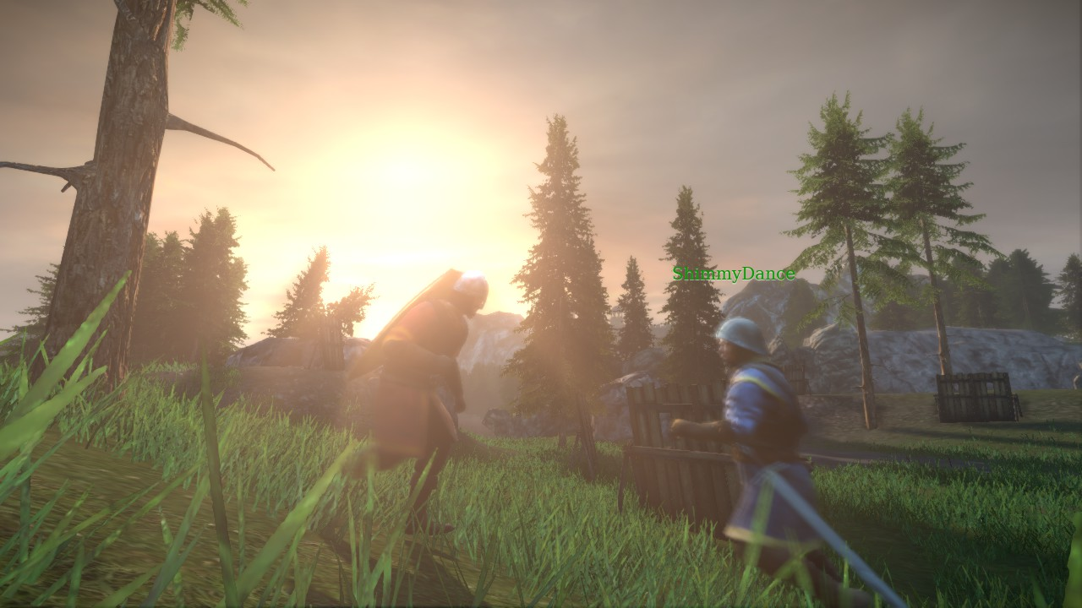
Played some Chivalry with some friends earlier today.

BuildistGuard
01-27-2013, 01:13 AM
That is why Windows 8 has no start button! I wish Windows 8 had a start menu preinstalled, or else I will hire someone to hack microsoft and literally destroy them!

Void
01-27-2013, 09:40 AM
(01-27-2013 01:13 AM)BuildistGuard Wrote: [ -> ]That is why Windows 8 has no start menu! I wish Windows 8 had a start menu preinstalled, or else I will hire someone to hack microsoft and literally destroy them!
They do have one, you just hate it too much to label it one.

Who
01-27-2013, 02:17 PM
https://www.youtube.com/watch?v=IKzGUve_Icg
Our blades are WINDOWS VISTA great!

VenomSinister
01-27-2013, 04:12 PM
(01-27-2013 02:17 PM)Who Wrote: [ -> ]https://www.youtube.com/watch?v=IKzGUve_Icg
Our blades are STUPID great!
That ad is the funniest I've seen.

Ghosty
02-08-2013, 09:35 AM
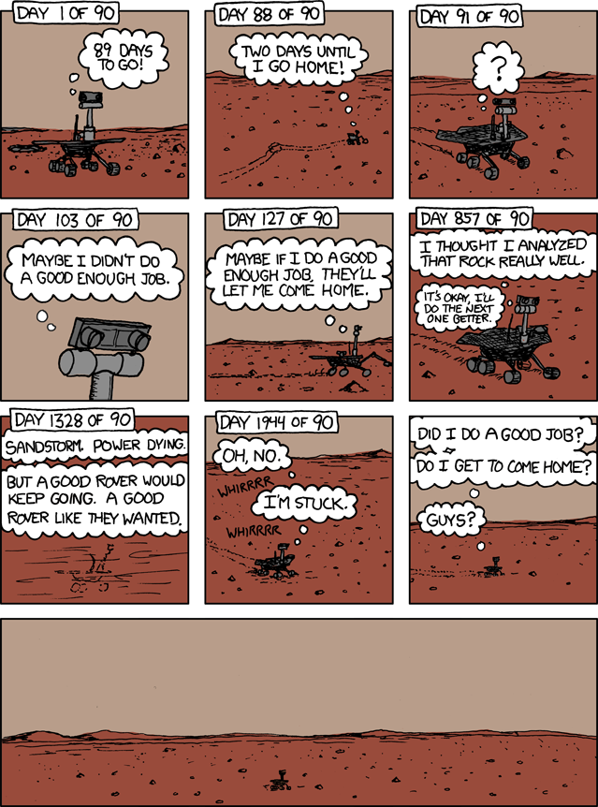
Suddenly I'm in a much sadder mood this morning.

02-09-2013, 06:24 AM
(01-27-2013 04:13 PM)BuildistGuard Wrote: [ -> ]
That is why Windows 8 has no start button! I wish Windows 8 had a start menu preinstalled, or else I will hire someone to hack microsoft and literally destroy them!
I rarely even use the start button. I have all the important programs on my desktop & the toolbar.

Oak
02-09-2013, 09:25 AM
I use the start bar a lot.
Windows 8 seems stupid from my eyes.

DysLabs
02-10-2013, 07:33 AM
I don't get it. Put your important programs on your hotbar. There is no need for the start menu.

Oak
02-10-2013, 11:05 AM
I don't even know what a damn hotbar is.
Stop using these stupid tech-terms and be a simple minimalist.

Legit
02-11-2013, 04:56 AM
http://i.imgur.com/K7X3Q.jpg
dat

Myem
02-11-2013, 05:12 AM
If only there was a male version of it.

Myem
02-23-2013, 04:12 PM
While I was looking at some recent dots, I noticed a 2DWords "black hole" around Missouri, Illinois, Arkansas, Louisiana, Kentucky, Mississippi, and Tennessee.
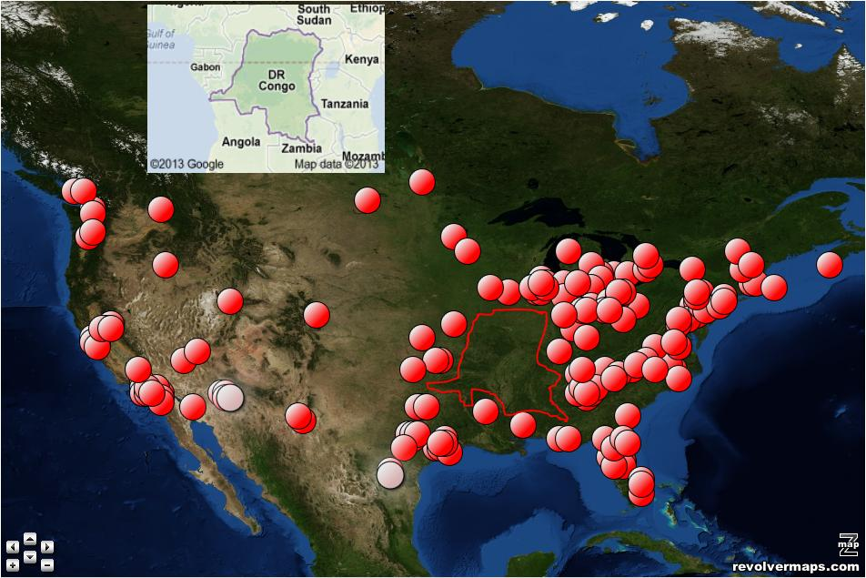

Ghosty
02-23-2013, 11:53 PM
I also see an old-fashioned hand-held telephone in the Northern Appalachians. (shrugs)

Myem
02-24-2013, 07:01 AM
(02-23-2013 11:53 PM)Ghosty Wrote: [ -> ]I also see an old-fashioned hand-held telephone in the Northern Appalachians. (shrugs)
You don't deserve to post on the same thread until you recognize how important this is to me.
BLANDFLAKESing disrespectful.

Ghosty
03-09-2013, 03:26 AM
Found some of my old MSPaint Roblox ads.... ahh, memories...

Oak
03-09-2013, 11:32 AM
(03-09-2013 03:26 AM)Ghosty Wrote: [ -> ]Found some of my old MSPaint Roblox ads.... ahh, memories...
<snip>
Such bad ads but catchy..

Void
03-09-2013, 11:46 AM
These are actually pretty clever

Oak
03-09-2013, 11:57 AM
I know, but really low-quality which makes those ads get little attention.

Ghosty
03-09-2013, 12:56 PM
They were made completely in MSpaint 2 years ago, before I got GIMP. Of course they're low quality.
(Also, the first one only makes sense if you know that the Pacman ghosts are called Inky, Blinky, Pinky, and Clyde.)

Myem
03-09-2013, 02:08 PM
(03-09-2013 11:32 AM)Oak Wrote: [ -> ]
(03-09-2013 03:26 AM)Ghosty Wrote: [ -> ]Found some of my old MSPaint Roblox ads.... ahh, memories...
<snip>
Such bad ads but catchy..
Hey Ghosty, why don't you snip the images in the Image Thread that were repeated twice because Oak quoted the entire post?

Oak
03-09-2013, 11:57 PM
(03-09-2013 02:08 PM)Myem Wrote: [ -> ]
(03-09-2013 11:32 AM)Oak Wrote: [ -> ]
(03-09-2013 03:26 AM)Ghosty Wrote: [ -> ]Found some of my old MSPaint Roblox ads.... ahh, memories...
<snip>
Such bad ads but catchy..
Hey Ghosty, why don't you snip the images in the Image Thread that were repeated twice because Oak quoted the entire post?
I didn't quote anything on the Image Thread..

Ghosty
03-10-2013, 12:15 AM
There was one post by Oak which quoted 3 images, including one of New York. I must not have seen it before. It's been <snip>ped.

Oak
03-10-2013, 04:05 AM
So what?

Myem
03-10-2013, 08:24 AM
(03-10-2013 04:05 AM)Oak Wrote: [ -> ]So what?
It's repetitive to quote 3 large images on a page that already has enough large images to destroy every computer that ghosty has ever had.

Oak
03-10-2013, 07:09 PM
(03-10-2013 08:24 AM)Myem Wrote: [ -> ]
(03-10-2013 04:05 AM)Oak Wrote: [ -> ]So what?
It's repetitive to quote 3 large images on a page that already has enough large images to destroy every computer that ghosty has ever had.
Does Ghosty still have Windows 97?
oooo
Pages: 1 2 3 4 5 6 7 8 9 10 11 12 13 14 15 16 17 18 19 20 21 22 23 24

Ghosty
03-10-2013, 11:29 PM
"Windows 97"
There is no GIF, video, or other similar type of media that can appropriately summarize how much I want to emphasize your obvious lack of time spent in the computer world that is so clearly displayed by you believing that Windows 97 is actually an operating system. You probably also believe that there is such a thing as a 99-dollar bill, too, or perhaps a speed limit of 64 miles per hour on certain highways. Perhaps you may even put faith in the belief of a PlayStation 2.9.

Oak
03-11-2013, 01:42 AM
(03-10-2013 11:29 PM)Ghosty Wrote: [ -> ]"Windows 97"
There is no GIF, video, or other similar type of media that can appropriately summarize how much I want to emphasize your obvious lack of time spent in the computer world that is so clearly displayed by you believing that Windows 97 is actually an operating system. You probably also believe that there is such a thing as a 99-dollar bill, too, or perhaps a speed limit of 64 miles per hour on certain highways. Perhaps you may even put faith in the belief of a PlayStation 2.9.
Perhaps you might believe that Mysty wants to bang you.

Ghosty
03-11-2013, 01:47 AM
It's rather fortunate for you that the "dumb" rating (along with all the others) is currently broken.

Oak
03-11-2013, 01:50 AM
Perhaps everyone would agree with me.
Perhaps I'd become famous.
Perhaps people would love me.
PERHAPS PERHAPS PERHAPS

Ghosty
03-11-2013, 01:51 AM
And perhaps you're a deluded young teenager with mental problems who must post whatever is on your mind, even when that whatever is something rather worthless, insulting, rude, or outright incorrect.

Leonartist
03-12-2013, 07:08 AM
Hello,
Thank you for taking the time to contact McIlhenny Company regarding TABASCO® brand Products. We apologize if your recent experience with our product was not a positive one.
If you have a problem with one of our products, we require that the product in question be returned so that our Quality Assurance Manager may have it tested. If you still have the product and you provide us with your complete mailing address, I would then send a self-addressed stamped envelope to have the product picked up. In order to expedite the Q/A process it would be very helpful if you could give us the following information; flavor, size, Best Buy Date and the lot code. All of this information can be found on the bottle. Upon receipt I will send you a replacement. However, if we do not get the product back, we cannot replace it.
Once again, I apologize for any inconvenience this may have caused. Thank you for your interest in our company and our products.
----------------------------------------------------------------------------------------------
I bought a bottle of Habanero Tabasco sauce, and I was very disapointed by it. When I bought the hot sauce I assumed that it would be much hotter than regular Tabasco, but when I used it, it tasted milder than regular Tabasco. "Some like it hot. But for those who like it hotter, there's TABASCO Habanero Suace.", is what the box said. I'm wondering if my hot sauce was defective or if it is supposed to be like this. I would also like to know the scoville units of the two hot sauces.
Thank you.

Innerwebs
03-13-2013, 08:38 AM
"Soy milk makes you gay" ~Leon 2013

Myem
03-13-2013, 10:14 AM
(03-13-2013 08:38 AM)Innerwebs Wrote: [ -> ]"Soy milk makes you gay" ~Leon 2013
Now why would Leonartist rate his own logic as dumb?

Omega
03-13-2013, 11:08 AM
Because he wants to deny it all, but...
WE'VE GOT CHATLOGS ON OUR SIDE
hehehehe

Ghosty
03-13-2013, 11:11 AM
(03-13-2013 11:08 AM)Omega Wrote: [ -> ]WE'VE GOT CHATLOGS ON OUR SIDE
hehehehe
I now have this really dumb urge to draw a picture of a guy with
[3/12/13] 18:42 Myem: leon answer me plz
tatooed on his hip.
Next to another guy with
[3/12/13] 18:31 Leonartist: Soymilk is satanic
tatooed on his waist.
Yeah. I'm weird.
03-13-2013, 11:17 AM
(03-13-2013 11:08 AM)Omega Wrote: [ -> ]Because he wants to deny it all, but...
WE'VE GOT CHATLOGS ON OUR SIDE
hehehehe
Speaking of chatlogs, here's the whole drama argument before Oak temporarily ruined it with the most boring and stupid topic starters ever.
ShowSpoiler:

Innerwebs
03-13-2013, 01:06 PM
(03-13-2013 10:14 AM)Myem Wrote: [ -> ]
(03-13-2013 08:38 AM)Innerwebs Wrote: [ -> ]"Soy milk makes you gay" ~Leon 2013
Now why would Leonartist rate his own logic as dumb?
He missed the agree button.

Oak
03-14-2013, 02:17 AM
Soy milk doesn't make you gay just because it has Estrogen and other hormones inside of it.
It can give you cancer depending on how much Soy you had.
leon u need some soy milk k

Myem
03-17-2013, 02:32 PM
Here's my /int/ flag folder so far, I just started a week ago so I missed a lot of eyegasmic flags over the year which I could've saved but didn't. I also haven't properly named the flags yet but I'll get to it pretty soon.
116 flags so far

BuildistGuard
03-17-2013, 02:41 PM
I'm working on a Sitcom that is about BuildistGuard, Void, Ghosty, Jacob_, Myem, and Oak who decide to build a Town called "2DWorlds". Yep you guessed, a Town based off this game, 2DWorlds. During the first day of 2DWorlds, PSY and Baauer play their Hit Songs "Gangnam Style" and "Harlem Shake", but chaos erupts!

Oak
03-17-2013, 11:13 PM
I can do the Harlem Shake.
THIS IS HOW YOU DO IT
shake your butt and tilt your head

Ghosty
03-17-2013, 11:22 PM
This is one of those moments that makes you say, "I sure would like for a creeper to come along right about now..."
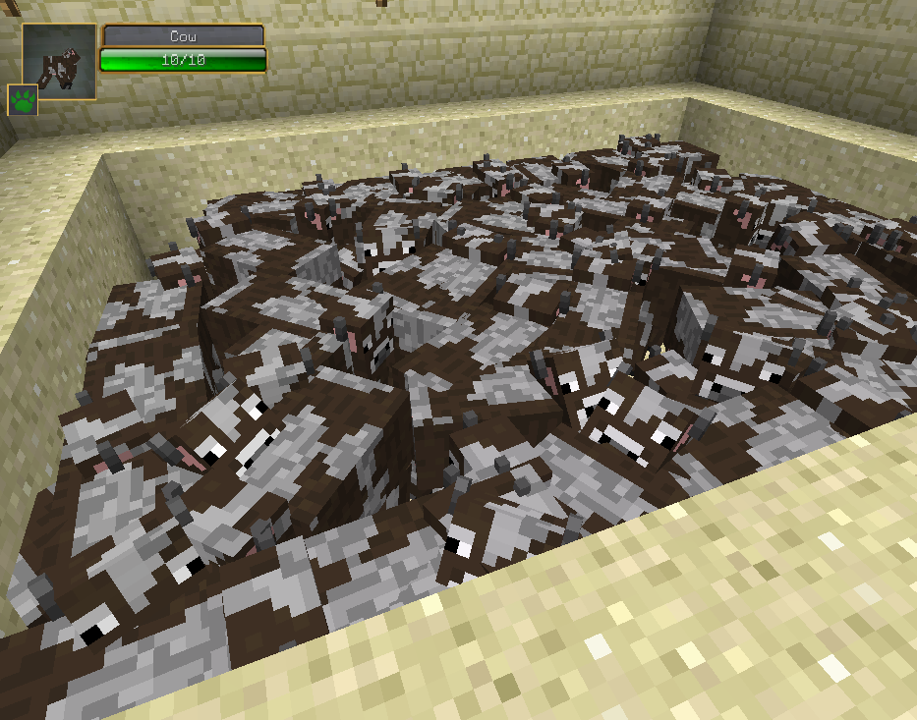

Oak
03-17-2013, 11:35 PM
(03-17-2013 11:22 PM)Ghosty Wrote: [ -> ]
ShowSpoiler:

aw look at those cows
also you have a ton of mods it seems

Ghosty
03-17-2013, 11:47 PM
Lol, only one mod is visible in that picture (Damage Indicators), and there's only two other mods installed at all.
Which is a huge variation from the 100+ I normally play with :P

Virtual
03-17-2013, 11:58 PM
Eww mincrift
03-18-2013, 12:28 AM
(03-17-2013 11:47 PM)Ghosty Wrote: [ -> ]Lol, only one mod is visible in that picture (Damage Indicators), and there's only two other mods installed at all.
Which is a huge variation from the 100+ I normally play with :P
You play with 100+ mods on Mienkrap?
SWEET JESUS
Now I know why you have such a terrible computer

Virtual
03-18-2013, 12:41 AM
Most Mindcrap mods are stupid

Ghosty
03-18-2013, 01:27 AM
(03-18-2013 12:28 AM)Oak Wrote: [ -> ]You play with 100+ mods on Mienkrap?
SWEET JESUS
Now I know why you have such a terrible computer
So you're implying that minecraft mods are viruses?
Because that's the only way that your statement makes much sense.
And I, and millions of other people, can assure you that IndustrialCraft 2, RedPower 2, ThaumCraft 3, EquivalentExchange 3, HarvestCraft, RailCraft, GregTech, Forestry, PortalGun, PaintMod, OptiFine, Rei's Minimap, Steve's Carts 2, Metallurgy 2, ComputerCraft, BuildCraft, DivineRPG, Thermal Expansion, Factorization, Mo' Creatures, ExtraBiomes XL, MystCraft, Not Enough Items, Wireless Redstone CBE, EnderChests, ChickenChunks, and Tinker's Construct are most absolutely not viruses.
And @Virtual, that may be true, because most of them are made by Java newbies, and add only one or two new ores and a new tool set, a variation on an existing mob, a handful of new food types, X-ray vision or flight, or some new stairs and other decostuff, but there are hundreds of well-written, comprehensive, enjoyable mods out there.

Myem
03-18-2013, 08:08 AM
(03-18-2013 01:27 AM)Ghosty Wrote: [ -> ]
(03-18-2013 12:28 AM)Oak Wrote: [ -> ]You play with 100+ mods on Mienkrap?
SWEET JESUS
Now I know why you have such a terrible computer
So you're implying that minecraft mods are viruses?
Because that's the only way that your statement makes much sense.
And I, and millions of other people, can assure you that IndustrialCraft 2, RedPower 2, ThaumCraft 3, EquivalentExchange 3, HarvestCraft, RailCraft, GregTech, Forestry, PortalGun, PaintMod, OptiFine, Rei's Minimap, Steve's Carts 2, Metallurgy 2, ComputerCraft, BuildCraft, DivineRPG, Thermal Expansion, Factorization, Mo' Creatures, ExtraBiomes XL, MystCraft, Not Enough Items, Wireless Redstone CBE, EnderChests, ChickenChunks, and Tinker's Construct are most absolutely not viruses.
And @Virtual, that may be true, because most of them are made by Java newbies, and add only one or two new ores and a new tool set, a variation on an existing mob, a handful of new food types, X-ray vision or flight, or some new stairs and other decostuff, but there are hundreds of well-written, comprehensive, enjoyable mods out there.
No, I think he implied that because you downloaded so much crap for MC that it is too laggy for any normal person to not attempt suicide over.

Ghosty
03-18-2013, 08:24 AM
(03-18-2013 08:08 AM)Myem Wrote: [ -> ]No, I think he implied that because you downloaded so much crap for MC that it is too laggy for any normal person to not attempt suicide over.
Then he doesn't know how computers work. Having a hard drive with only 1 GB free space doesn't add any more lag than having one with 50 GB free space.

Myem
03-18-2013, 08:26 AM
(03-18-2013 08:24 AM)Ghosty Wrote: [ -> ]
(03-18-2013 08:08 AM)Myem Wrote: [ -> ]No, I think he implied that because you downloaded so much crap for MC that it is too laggy for any normal person to not attempt suicide over.
Then he doesn't know how computers work. Having a hard drive with only 1 GB free space doesn't add any more lag than having one with 50 GB free space.
No, I meant that running all those mods at the same time on MC must've been taking a toll on your frame rate.
Why the hell did you imply that?

Oak
03-18-2013, 09:45 AM
(03-18-2013 08:24 AM)Ghosty Wrote: [ -> ]
(03-18-2013 08:08 AM)Myem Wrote: [ -> ]No, I think he implied that because you downloaded so much crap for MC that it is too laggy for any normal person to not attempt suicide over.
Then he doesn't know how computers work. Having a hard drive with only 1 GB free space doesn't add any more lag than having one with 50 GB free space.
you need a macintosh
support steve jobs' corpse

Ghosty
03-18-2013, 10:38 AM
Macintoshes have hard drives that work the same way too, Mr. Computer-Know-It-All.

Oak
03-19-2013, 08:20 AM
(03-18-2013 10:38 AM)Ghosty Wrote: [ -> ]Macintoshes have hard drives that work the same way too, Mr. Computer-Know-It-All.
Of all people, don't call me a "Mr. Computer-Know-It-All", that is what you should be labeling yourself.

Ghosty
03-19-2013, 10:47 AM
SARCASM, MY DEAR OAKSON.
Pages: 1 2 3 4 5 6 7 8 9 10 11 12 13 14 15 16 17 18 19 20 21 22 23 24

Oak
03-20-2013, 11:54 PM
AND MACS HAVE 6-10 HOUR BATTERY LIFE
PC'S HAVE UNDER 2 ON AVERAGE

Void
03-21-2013, 05:28 AM
(03-20-2013 11:54 PM)Oak Wrote: [ -> ]AND MACS HAVE 6-10 HOUR BATTERY LIFE
PC'S HAVE UNDER 2 ON AVERAGE
Excuse me, where did you get this terribly false fact?

Oak
03-21-2013, 08:14 AM
Void, it's not false. I have had many prior experiences with PC's. They all suck.

Ghosty
03-21-2013, 08:31 AM
(03-21-2013 08:14 AM)Oak Wrote: [ -> ]Void, it's not false. I have had many prior experiences with PC's. They all suck.
Ditto for me with Macs.
ALL electronics EVERYWHERE have some extent of suckishness.
Eventually, it gets to the point where you, and the world, get used to certain aspects of the suckishness and decide that they're better than those other guys' aspects of suckishness.
PCs can catch viruses on the web. That sucks.
You have to completely disassemble a Mac if your hard drive crashes. That sucks.
PCs have so many different component brands that it's hard to have a standard. That sucks.
Macs can only have Apple stuff. If there's a problem with that Apple stuff, too bad, you're stuck with it. That sucks.

Oak
03-21-2013, 08:39 AM
Ghosty isn't so savvy after all, heh?
On a Mac you can run ANY operating system USING Bootcamp.

Ghosty
03-21-2013, 08:42 AM
I was referring to hardware. Sorry if I didn't make that obvious.
And, according to Wikipedia, "However, with the release of Boot Camp 5.0 for OS X Mountain Lion version 10.8.3, only 64-bit versions of Windows 7 and Windows 8 are officially supported. Users have also installed Linux using the utility, although Apple has not listed support for Linux operating systems."
So if you wreck your stuff with a Mac on a non-Mac OS and you're not using Windows 7 or Windows 8, you're screwed, Apple won't help you at all.

Oak
03-21-2013, 10:38 AM
You can't use Linux on Bootcamp, big deal! No need for a nerd-rage.

Void
03-21-2013, 10:47 AM
(03-21-2013 10:38 AM)Oak Wrote: [ -> ]You can't use Linux on Bootcamp, big deal!

(03-21-2013 08:39 AM)Oak Wrote: [ -> ]On a Mac you can run ANY operating system USING Bootcamp.
If you're going to argue for something, don't contradict yourself.

Oak
03-21-2013, 10:52 AM
OK, so you can't use every OS.

Jacob_
03-21-2013, 11:31 AM
Overheard in the hipster part of NC: "I haven't seen convincing evidence that reptilian people don't exist"

Oak
03-21-2013, 01:27 PM
Where exactly IS this "hipster" part of North Carolina?

EvilOne
03-21-2013, 01:36 PM
(03-21-2013 08:31 AM)Ghosty Wrote: [ -> ]
(03-21-2013 08:14 AM)Oak Wrote: [ -> ]Void, it's not false. I have had many prior experiences with PC's. They all suck.
Ditto for me with Macs.
ALL electronics EVERYWHERE have some extent of suckishness.
Eventually, it gets to the point where you, and the world, get used to certain aspects of the suckishness and decide that they're better than those other guys' aspects of suckishness.
PCs can catch viruses on the web. That sucks.
You have to completely disassemble a Mac if your hard drive crashes. That sucks.
PCs have so many different component brands that it's hard to have a standard. That sucks.
Macs can only have Apple stuff. If there's a problem with that Apple stuff, too bad, you're stuck with it. That sucks.
False
PC is the best and has 0% Flaws. But Xbox has 99.9% Flaws and PS3 has 0% Flaws so to some extend I am not happy with Microsoft. (Apple has 99.9.9999999999% Flaws) That .000001 is not a flaw because I think Apple is a cool company name.

Oak
03-21-2013, 01:42 PM
Xbox and PS3 aren't an operating system though..
they are stupid console gaming systems

EvilOne
03-21-2013, 01:46 PM
(03-21-2013 01:42 PM)Oak Wrote: [ -> ]Xbox and PS3 aren't an operating system though..
they are stupid console gaming systems
I know. I brought em' up because Xbox is made by Microsoft and Microsoft made PC and we are talking about how great PC is amirite?

Ghosty
03-22-2013, 12:02 AM
Actually, PS2 and Xbox have OSes. They are not PC operating systems, but they are just as much an operating system as a Mac OS because they are made to work on a specific model of computer made by one company.

(03-21-2013 11:31 AM)Jacob_ Wrote: [ -> ]Overheard in the hipster part of NC: "I haven't seen convincing evidence that reptilian people don't exist"
Well, technically, you can't prove a negative...

Oak
03-22-2013, 11:47 AM
Everything has flaws, Excel. But not Macintosh. 100% flawless.

Myem
03-22-2013, 01:35 PM
So over the week I gained several new pretty flags after intense lurking. I'm most proud of getting Turkmenistan, and I've got most of Central Asia with Tajikistan being the last one in the region that'll need to lurk more for. I will post the screenshot of my updated /int/-/sp/ flag collection folder tomorrow.

BuildistGuard
03-22-2013, 09:24 PM
I have feeling that the OTers of Roblox is going to raid us anytime soon:
http://www.roblox.com/Forum/ShowPost.asp...D=92465999

Oak
03-23-2013, 01:42 PM
(03-22-2013 09:24 PM)BuildistGuard Wrote: [ -> ]I have feeling that the OTers of Roblox is going to raid us anytime soon:
http://www.roblox.com/Forum/ShowPost.asp...D=92465999
I swear Minish the imposter made that thread to get back at us. It figures why so many new accounts joined today.

Myem
03-23-2013, 03:06 PM
(03-17-2013 02:32 PM)Myem Wrote: [ -> ]
ShowSpoiler:

116 flags.
Just like I promised, here's my updated flag collection folder.
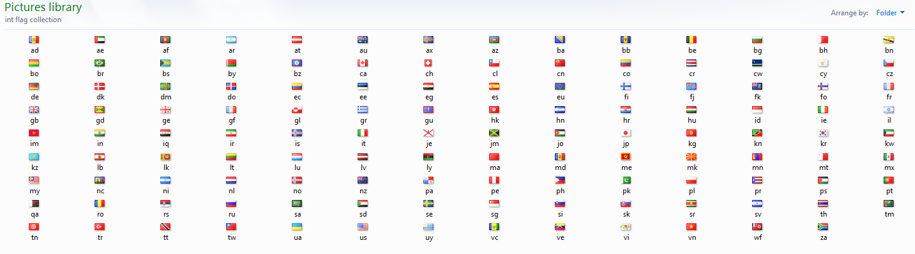
I have 125 flags now.
I almost got Aruba and Armenia but the posts 404'd.

Ghosty
03-23-2013, 11:18 PM
200 posts in the Chaos thread.
Took us long enough to get back here.

Oak
03-24-2013, 06:21 AM
Wasn't it roughly 200 posts on the Buildism Chaos Thread as well?

Ghosty
03-24-2013, 07:37 AM
On the first or second? The second, maybe, but the first probably had around 500.

Myem
03-24-2013, 05:57 PM
(03-23-2013 03:06 PM)Myem Wrote: [ -> ]
(03-17-2013 02:32 PM)Myem Wrote: [ -> ]
ShowSpoiler:

116 flags.
ShowSpoiler:

125 flags.
I took some time to give them proper names, and I've also gained two new flags, Armenia and the Maldines.
127 flags.

Myem
03-24-2013, 06:59 PM
I made a mistake, "Maldines" should be "Maldives."

Ghosty
03-24-2013, 11:10 PM
Rather impressive.
I once had a HUGE collection of NASCAR icons that I gathered from the online leaderboards from 2007 through 2009, like about 400 individual renderings. I have no idea if I still have any copy of that saved anywhere, though.

VenomSinister
03-24-2013, 11:39 PM
Btw it's not Aland its Åland. I have the åöä's on my keyboard ;3

Myem
03-25-2013, 12:27 AM
I know that, I was just too lazy to copy paste that in and doubted that any of you guys would've noticed.

Myem
03-25-2013, 07:52 AM
(03-24-2013 05:57 PM)Myem Wrote: [ -> ]
(03-23-2013 03:06 PM)Myem Wrote: [ -> ]
(03-17-2013 02:32 PM)Myem Wrote: [ -> ]
ShowSpoiler:

116 flags.
ShowSpoiler:

125 flags.
ShowSpoiler:

127 flags.
I corrected the spelling errors and I've gained two new flags since I last posted, Cambodia and Myanmar/Burma, which are both in Southeast Asia.
129 flags.

Myem
03-25-2013, 09:36 AM
Speaking of the Maldives, the government of it has seriously been considering relocating the entire country because of climate change.
Here's one of many search results that mention this: http://www.smh.com.au/environment/climat...1pobf.html
This is where the Maldives are:
This is what the Maldives archipelago looks like:
This is what the capital and largest city of the Maldives, Malé, looks like:

Ghosty
03-25-2013, 11:11 PM
There was talk of them having to relocate in the early '90s. None of the islands is more than 6 feet (either that or 6 meters...) above sea level, if I remember correctly. So yeah, global warming is a very, very serious problem for them.

Oak
03-27-2013, 01:17 AM
Wow, the Maldives are really pretty but it's scary how low-lying and small the island is. Geographically, it seems to be similar to Malta.

Myem
03-27-2013, 08:23 AM
(03-25-2013 07:52 AM)Myem Wrote: [ -> ]
(03-24-2013 05:57 PM)Myem Wrote: [ -> ]
(03-23-2013 03:06 PM)Myem Wrote: [ -> ]
(03-17-2013 02:32 PM)Myem Wrote: [ -> ]
ShowSpoiler:

116 flags.
ShowSpoiler:

125 flags.
ShowSpoiler:

127 flags.
ShowSpoiler:

129 flags.
New flags: Nepal, Bangladesh, and Zimbabwe.
133 flags.

Oak
03-29-2013, 04:58 AM
CRACK DOWN ON MUGABE!
SAY N-O TO MUGABE
N-O TO MUGABE'S ZIMBABWE!
bring back rhodesia pls so mugabe can live in a sewer

Ghosty
04-01-2013, 04:51 AM
SoundCloud added a new "Here's the Drop!" feature today. It's stupidly inaccurate most of the time so far...
But there is at least one case of it being hilariously accurate.
Check out the 'drop' here.
EDIT: Aw well... They removed it again. But it was... "Deploying surprise in 5. 4. 3. [HERE'S THE DROP!™ --->] Time out for a second. That wasn't supposed to happen."

Myem
04-06-2013, 08:33 AM
143 flags.

Myem
04-09-2013, 10:23 AM
146 flags.

Ghosty
04-10-2013, 08:06 AM
The good thing about being sick?
I get to sit around doing nothing, watching Disney movies with Mysty.
ShowSpoiler:

Myem
04-11-2013, 09:30 AM
"help fight thread pollution"
Why did you steal Jacob_'s exact phrase?

Myem
04-11-2013, 09:36 AM
149 flags.

Leonartist
04-16-2013, 10:39 AM
DEAREST ONE
To: Leonartist
Dearest One,
I am Alima Coulibaly Ammed 19 years old female from the Republic of Ivory Coast,West Africa, am the Daughter of Late Chief Sgt Ibrahim Coulibaly Ammed (a.k.a General IB ). My late father was a well known Ivory Coast militia leader . He died on Thursday 28 April 2011 following a fight with the Republican Forces of Ivory Coast(FRCI)
I am seeking for long term relationship and investment assistance. My father of blessed memory deposited One big trunk boxes containing $3.5musd(Three million five hundred thousand united states dollar) here in Cote d'Ivoire with my name as the next of kin.
I had contacted the comapny to clear the deposit but the Manager told me that my status according to the local law does not authorize me to carry out the operation. However, he advised me to provide a trustee who will stand on my behalf preferably a foreigner since I do not want to stay in this country again.
Therefore, I decide to seek for your help in transferring of the box into your country while I will relocate to your country and settle down there. As you indicated your interest to help me I will give you the contact of the company where my late beloved father deposited the box with my name as the next of kin.
It is my intention to compensate you with 20% of the total money for your assistance and the balance shall be my investment in any profitable venture which you will recommend to me as I have no any idea about foreign investment.
I will give you more details in my next mail after receiving your acceptance to help me.
reply me to Email (alimaammed@yahoo.com)
Yours sincerely
Alima Coulibaly Ammed.
This is a PM I got.

Ghosty
04-16-2013, 11:09 AM
Lol, I thought those spambots died out years ago.

Void
04-16-2013, 11:42 AM
(04-16-2013 11:09 AM)Ghosty Wrote: [ -> ]Lol, I thought those spambots died out years ago.
~2027
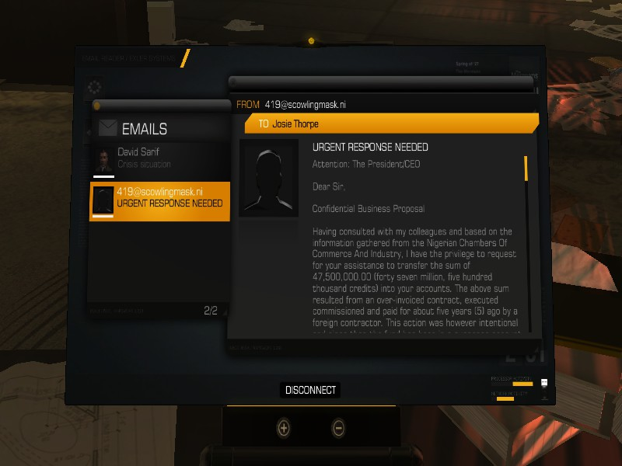

Innerwebs
04-16-2013, 11:47 AM
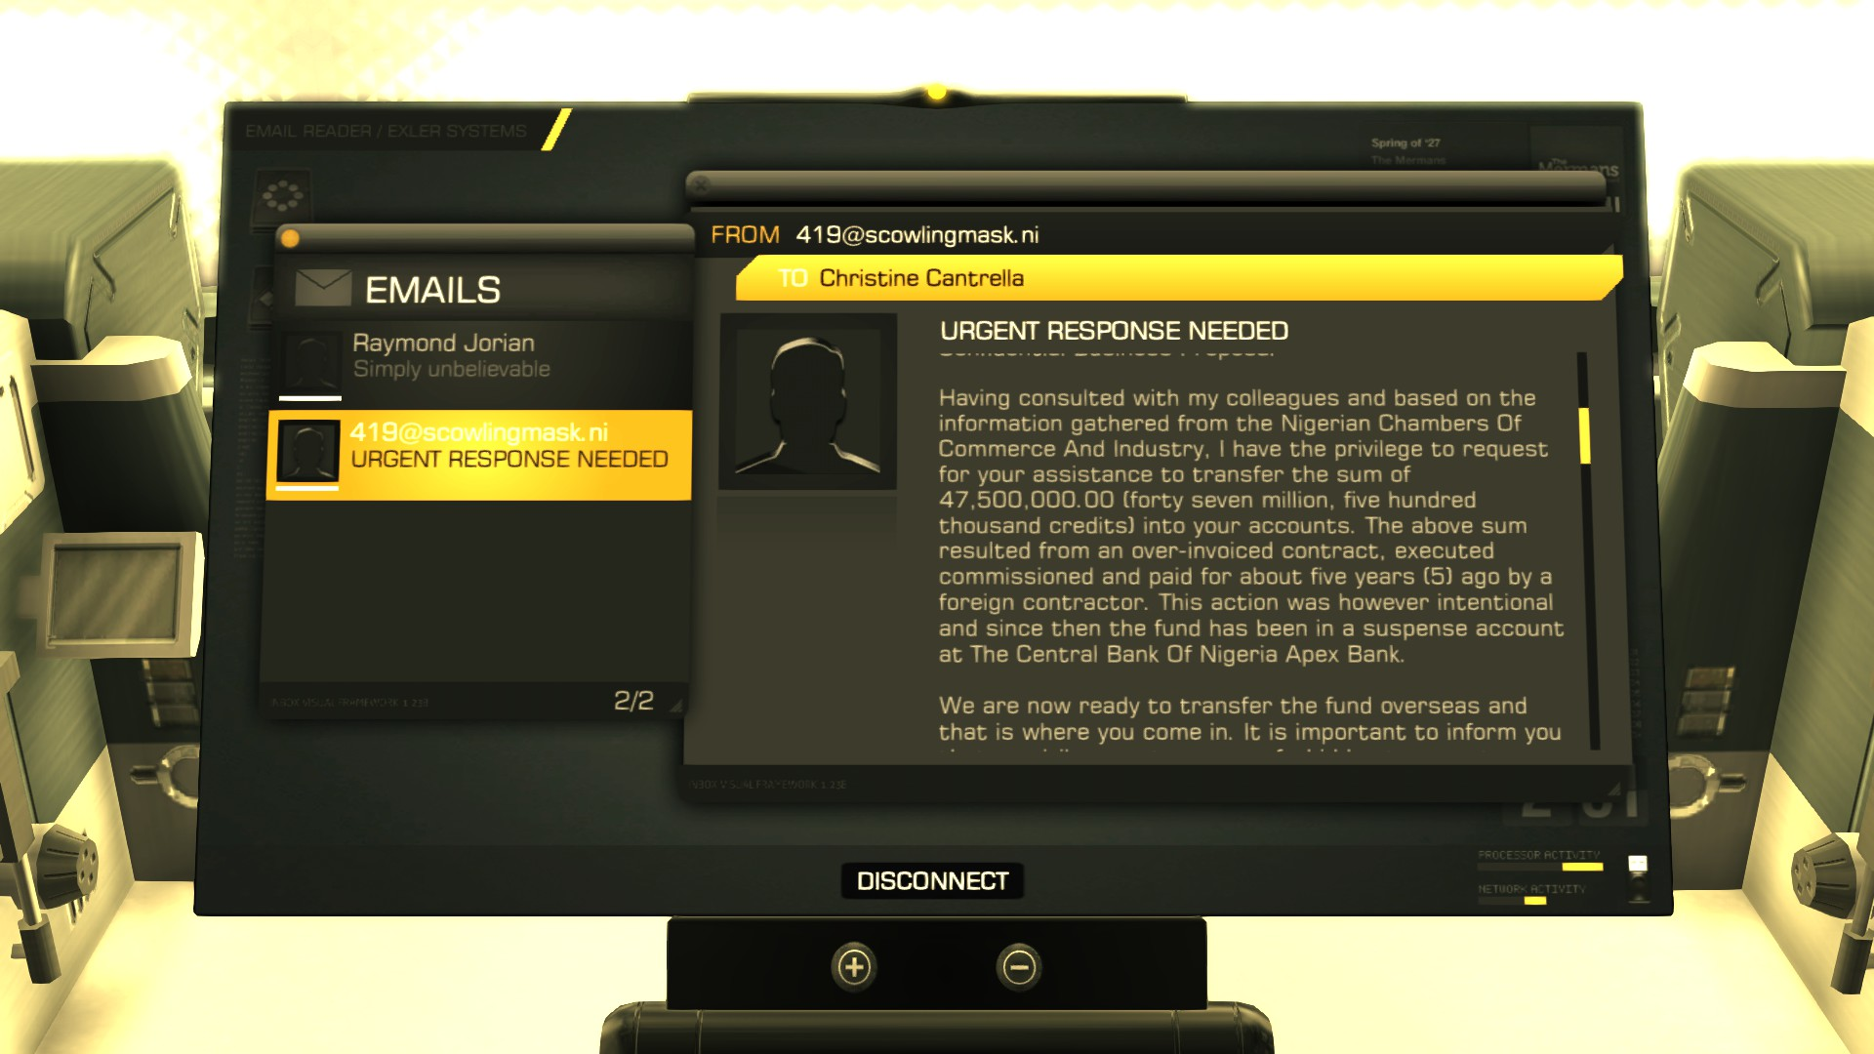
Those spam emails are really prominent in the future.

Jacob_
04-16-2013, 12:26 PM
Looks like one of our own is a griefer on my favorite Minecraft server

DysLabs
04-17-2013, 06:29 AM
(04-16-2013 12:26 PM)Jacob_ Wrote: [ -> ]
Looks like one of our own is a griefer on my favorite Minecraft server
Hi u ok.

DysLabs
04-17-2013, 06:32 AM
Btw, minecraftbros0 made that sign.

Myem
04-17-2013, 07:24 AM
>playing MC
BARACK OBAMAing dirty pieces of jews.

Innerwebs
04-21-2013, 12:16 PM
This reminds me of BG

Minecraft
04-21-2013, 12:19 PM
Okokok

